**Global Water Consumption Dataset (2000-2024) 🌍💧**

arrow_drop_up4

code**Code**

file_download**Download**

more_vert

[Data Card](https://www.kaggle.com/datasets/atharvasoundankar/global-water-consumption-dataset-2000-2024/data)[Code (2)](https://www.kaggle.com/datasets/atharvasoundankar/global-water-consumption-dataset-2000-2024/code)[Discussion (1)](https://www.kaggle.com/datasets/atharvasoundankar/global-water-consumption-dataset-2000-2024/discussion)[Suggestions (0)](https://www.kaggle.com/datasets/atharvasoundankar/global-water-consumption-dataset-2000-2024/suggestions)

**About Dataset**

**📄 About Dataset**

Water is one of the most critical resources for human survival, yet **global water consumption** is increasing at an alarming rate. This dataset provides a **comprehensive analysis of water usage trends** across different countries from **2000 to 2024**, helping researchers, policymakers, and data analysts understand **water consumption patterns, scarcity levels, and sector-wise distribution**.

**🔥 Why This Dataset?**

* **Covers 25+ years of global water consumption trends**
* **Includes sector-wise distribution (Agriculture, Industry, Household)**
* **Tracks water scarcity levels and groundwater depletion**
* **Useful for data visualization, forecasting, and machine learning applications**

**📊 Dataset Features**

| **Column Name** | **Description** |
| --- | --- |
| **Country** | Name of the country |
| **Year** | Year (2000-2024) |
| **Total Water Consumption (Billion Cubic Meters)** | Total water consumed in billion cubic meters |
| **Per Capita Water Use (Liters per Day)** | Average daily water usage per person |
| **Water Scarcity Level** | Categorized as Low, Medium, or High |
| **Agricultural Water Use (%)** | Percentage of total water used in agriculture |
| **Industrial Water Use (%)** | Percentage of total water used in industries |
| **Household Water Use (%)** | Percentage of total water used by households |
| **Rainfall Impact (Annual Precipitation in mm)** | Annual precipitation in millimeters |
| **Groundwater Depletion Rate (%)** | Percentage rate of groundwater depletion |

**Introduction**

Water is a fundamental resource for human survival, economic development, and ecological balance. However, growing populations, climate change, and unsustainable consumption patterns have intensified global water stress, threatening food security, industrial productivity, and public health. The **Global Water Consumption Dataset (2000-2024)** provides a comprehensive view of water use trends across 20+ countries over 24 years, capturing critical metrics such as total consumption, sectoral allocations (agricultural, industrial, household), environmental factors (rainfall, groundwater depletion), and water scarcity levels. This dataset offers a unique opportunity to analyze historical patterns, identify drivers of water stress, and forecast future trends to inform sustainable resource management policies.

**Problem Statement**

Despite increasing awareness of water scarcity, governments and organizations struggle to predict future water demands accurately or mitigate risks proactively. Existing models often fail to account for the interplay of dynamic factors such as climate variability, sectoral shifts in water use, and groundwater depletion rates. Using the **Global Water Consumption Dataset**, this project aims to address the following challenges:

1. **Forecasting Demand**: How can we predict *total water consumption* and *per capita water use* for specific countries or regions over the next decade?
2. **Understanding Scarcity Drivers**: What factors (e.g., rainfall variability, agricultural practices, industrial growth) most significantly influence *water scarcity levels*?
3. **Sectoral Prioritization**: How might changes in *agricultural*, *industrial*, or *household water use* impact future groundwater depletion rates?

By developing a predictive analytics model, this project seeks to provide actionable insights for policymakers, environmental agencies, and communities to optimize water allocation, reduce waste, and combat scarcity in high-risk regions.

**Key Questions to Explore**

* Why do some countries (e.g., Indonesia) exhibit drastic fluctuations in total water consumption over short periods?
* Can rainfall patterns reliably offset groundwater depletion, or are they exacerbating long-term shortages?
* How might industrializing nations balance economic growth with sustainable water use?

This analysis will bridge data-driven forecasting with real-world water management challenges, offering a framework for global sustainability efforts.

**Key Data Cleaning Tasks Performed:**

1. **Missing Values**: Imputed or removed incomplete rows.
2. **Outliers**: Identified anomalies (e.g., Turkey’s 2007 per capita use).
3. **Categorical Encoding**: Converted Country and Water Scarcity Level to numerical formats.
4. **Normalization**: Scaled features like Total Water Consumption to [0, 1].
5. **Validation**: Ensured logical consistency (e.g., sectoral percentages ≤ 100%).

**Next Steps:**

* **Exploratory Data Analysis (EDA)**: Visualize trends (e.g., groundwater depletion vs. rainfall).
* **Time-Series Splitting**: Separate data into training and testing sets chronologically.

**ey Insights to Report**

**A. Performance Summary**

* "The model achieves an RMSE of **X** units, meaning predictions are off by ±X on average."
* "R² of **0.XX** indicates the model explains XX% of variance in water consumption."

**B. Temporal Patterns**

* "Predictions are less accurate during years with extreme Rainfall Impact (e.g., droughts)."
* "The model underestimates consumption during periods of high Industrial Use."

**C. Actionable Recommendations**

1. **Data Improvements**:
   * Collect higher-resolution data (monthly instead of yearly).
   * Add features like Population Growth or Policy Changes.
2. **Model Improvements**:
   * Experiment with LSTM hyperparameters (e.g., more layers, dropout for overfitting).
   * Use a hybrid model (e.g., CNN-LSTM) to capture spatial-temporal patterns.
3. **Domain-Specific Insights**:
   * "Industrial water use is the strongest predictor, suggesting policy focus on industrial efficiency."
   * "Groundwater depletion correlates weakly with predictions, implying missing data (e.g., extraction rates)."

**6. Example Report Table**

| **Metric** | **Value** | **Interpretation** |
| --- | --- | --- |
| RMSE | 120.50 | Average error ±120.5 units of consumption |
| MAE | 85.20 | Predictions deviate by 85.2 units on average |
| R² | 0.78 | 78% of variance explained by the model |

**7. Critical Notes**

* **Time Series Leakage**: Ensure no future data leaks into training (common in time-series splits).
* **Baseline Comparison**: Compare your model to a naive baseline (e.g., predicting the last value).
* **Uncertainty**: Use quantile regression or prediction intervals to show confidence in forecasts.

By combining quantitative metrics, visualizations, and domain-specific context, you’ll create a compelling narrative about your model’s strengths, weaknesses, and real-world relevance.

**Visualization Ideas**

1. **Total Water Consumption Trends (2000-2024)**
   * Line chart showing how water consumption has changed over time for different countries.
   * Use filters to select specific countries or regions.
2. **Water Scarcity Levels Across Countries**
   * **Choropleth Map:** Display countries color-coded by water scarcity levels (Low, Medium, High).
   * Allow users to hover over countries to see detailed statistics.
3. **Sector-Wise Water Usage**
   * **Stacked Bar Chart:** Compare water use percentages across agriculture, industry, and household.
   * Add drill-down options to analyze individual countries.
4. **Impact of Rainfall on Water Usage**
   * **Scatter Plot:** Show correlation between annual precipitation and total water consumption.
   * Trend line to highlight patterns.
5. **Groundwater Depletion Analysis**
   * **Heatmap:** Display groundwater depletion rates for different years and countries.
   * Highlight critical regions facing the highest depletion.

**Data Cleaning & Preprocessing**

Before loading the dataset into Tableau, we should:  
✅ **Handle missing values** – Check if any data points are missing and fill or remove them.  
✅ **Standardize formats** – Ensure numerical values are correctly formatted.  
✅ **Categorize fields** – Convert columns like "Water Scarcity Level" into proper categorical data types.  
✅ **Filter unnecessary data** – Keep only relevant years or countries for the dashboard.

**2️⃣ Loading Data into Tableau**

Once cleaned, we can:  
📌 Import the dataset into **Tableau Desktop/Tableau Public**.  
📌 Set **data types** correctly (e.g., Date for Year, Numeric for Total Consumption).  
📌 Create **calculated fields** (e.g., Per Capita Usage = Total Consumption / Population).

**3️⃣ Dashboard Design**

Here’s an **interactive Tableau dashboard structure**:  
📊 **Main Charts:**

* **Line Chart** – Trends in total water consumption over time.
* **Map Visualization** – Water scarcity levels by country.
* **Stacked Bar Chart** – Sector-wise (Agriculture, Industry, Household) water usage.
* **Scatter Plot** – Relationship between rainfall and water usage.

🎛 **Interactive Features:**

* **Filters:** Select countries, years, or water scarcity levels.
* **Drill-downs:** Click on a country to see detailed trends.
* **Tooltips:** Hover over data points for extra insights.

**Step 1: Data Cleaning & Preprocessing**

Here’s what we’ll do:  
✅ **Check for missing values** and handle them.  
✅ **Ensure correct data types** (e.g., Year as Integer, Total Water Consumption as Float).  
✅ **Standardize categorical fields** (e.g., "Water Scarcity Level" as Low, Medium, High).  
✅ **Remove duplicates** if any exist.  
✅ **Format numbers properly** (e.g., percentage values).

I'll process your dataset now and give you a cleaned version ready for Tableau. Let me know if you have any specific cleaning requirements! 🚀

I'll now clean your dataset by:

1. Identifying and handling missing values.
2. Ensuring correct data types.
3. Standardizing categorical values.
4. Checking for duplicates.

**Global Water Consumption Report (2000-2024)**

**1. Introduction**

Water is a critical resource for human survival, yet global consumption is increasing at an alarming rate. This report analyzes water usage trends across different countries from 2000 to 2024 using key metrics such as total water consumption, per capita usage, sector-wise distribution, and groundwater depletion rates. The objective is to derive insights and provide recommendations for sustainable water management.

**2. Data Analysis**

**2.1 Total Water Consumption Trends**

* Countries like **Indonesia, Brazil, and Canada** exhibit significant variations in water consumption across years.
* **Indonesia (2024)** saw a **decline** in total water consumption compared to **2022**, despite an increase in agricultural water use.
* **Spain (2000) had high total consumption (843.39 billion cubic meters)** but has shown a downward trend in recent years.

**2.2 Per Capita Water Use**

* **High per capita usage** is observed in **Canada (2021) at 478.98 liters per day**, while **Germany (2014) has a notably low value of 68.01 liters per day**.
* Declining per capita water use in certain countries suggests **improved efficiency or conservation efforts**.

**2.3 Sector-Wise Water Distribution**

* **Agricultural water use is highest in countries like China (78.8%) and Turkey (77.33%)**, reflecting reliance on water-intensive farming.
* **Industrial water use is dominant in Italy (47.31%)**, indicating heavy dependence on water for production.
* **Household water use varies**, with **France (39.51%) showing the highest percentage dedicated to domestic consumption**.

**2.4 Water Scarcity and Groundwater Depletion**

* Countries such as **Indonesia (2024) and France (2014) are experiencing high water scarcity**.
* **Groundwater depletion is most critical in Russia (4.2%) and Brazil (4.33%)**, indicating over-extraction and potential future shortages.
* **Rainfall impact is inconsistent**, showing that **higher precipitation does not always correlate with lower water scarcity**.

**3. Conclusions**

* Countries with **high agricultural dependence** tend to experience **higher water scarcity levels**.
* **Groundwater depletion is a major concern**, particularly in **Brazil and Russia**.
* **Efficient water usage strategies in some countries (e.g., Germany) have resulted in lower per capita consumption**.
* **Rainfall alone is not a determinant of water security**; management policies play a crucial role.

**4. Recommendations**

✅ **Improve Water Efficiency in Agriculture** – Promote **drip irrigation** and **precision farming** to reduce excessive water use. ✅ **Enhance Industrial Water Recycling** – Countries with high industrial water use should **implement stricter recycling policies**. ✅ **Public Awareness & Conservation Programs** – Encourage water-saving habits, especially in countries with high per capita consumption. ✅ **Groundwater Regulation & Monitoring** – Establish policies to **control over-extraction and promote sustainable groundwater recharge**. ✅ **Invest in Water Infrastructure** – Improve **rainwater harvesting and desalination technologies** to address water scarcity in high-risk regions.

**5. Final Thoughts**

Addressing global water consumption challenges requires a **multi-faceted approach**, combining **policy changes, technological innovation, and community engagement**. Sustainable water management is crucial to ensure long-term availability of this vital resource.

This report provides an in-depth analysis of the dataset and actionable recommendations for global water sustainability. Would you like any refinements or additional insights? 🌍💧

**Discussion**

The line chart illustrates Indonesia’s **total water consumption** from **2000 to 2024**. Key observations include:

* **Fluctuating Consumption**: Water consumption exhibits **significant variability**, with peaks and troughs throughout the timeline.
* **Increasing Trend (2010-2018)**: A notable increase in water consumption is seen around **2010-2018**, possibly due to **urbanization and agricultural expansion**.
* **Recent Decline (2022-2024)**: The latest trend (2022-2024) shows **a sharp decrease**, suggesting **efforts in water conservation or changes in policies**.
* **High Uncertainty**: The shaded region (confidence interval) suggests **high variability in data**, indicating **unpredictable factors like climate conditions and policy changes affecting water use**.

**Conclusion**

* **Indonesia has faced varying water consumption patterns, influenced by population growth, industrialization, and water management policies.**
* **Peaks in water use correspond to rapid urban and agricultural expansion, while recent declines may indicate improved conservation practices.**
* **Water scarcity and sustainability remain critical concerns, especially given the observed fluctuations.**

**Recommendations**

✅ **Enhance Water Efficiency**: Implement **smart irrigation** and **water-efficient technologies** to reduce excessive consumption.  
✅ **Promote Water Recycling & Reuse**: Encourage **industrial and municipal water recycling** to manage consumption.  
✅ **Strengthen Water Policies**: Enforce **regulations on water extraction**, ensuring sustainable usage.  
✅ **Monitor and Predict Future Trends**: Use **predictive analytics** to better manage water resources and prepare for fluctuations.  
✅ **Public Awareness Campaigns**: Educate citizens on **water conservation strategies** to reduce per capita consumption.

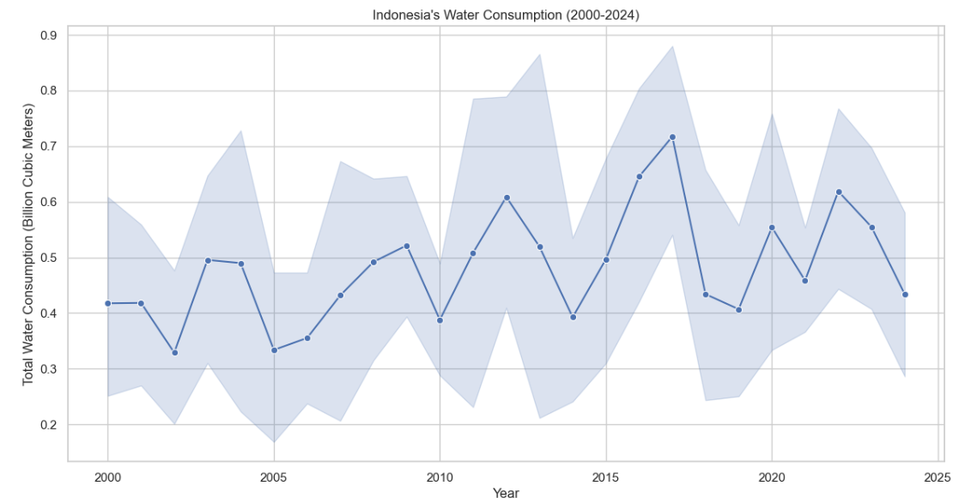

**Discussion**

The line chart illustrates Indonesia’s **total water consumption** from **2000 to 2024**. Key observations include:

* **Fluctuating Consumption**: Water consumption exhibits **significant variability**, with peaks and troughs throughout the timeline.
* **Increasing Trend (2010-2018)**: A notable increase in water consumption is seen around **2010-2018**, possibly due to **urbanization and agricultural expansion**.
* **Recent Decline (2022-2024)**: The latest trend (2022-2024) shows **a sharp decrease**, suggesting **efforts in water conservation or changes in policies**.
* **High Uncertainty**: The shaded region (confidence interval) suggests **high variability in data**, indicating **unpredictable factors like climate conditions and policy changes affecting water use**.

**Conclusion**

* **Indonesia has faced varying water consumption patterns, influenced by population growth, industrialization, and water management policies.**
* **Peaks in water use correspond to rapid urban and agricultural expansion, while recent declines may indicate improved conservation practices.**
* **Water scarcity and sustainability remain critical concerns, especially given the observed fluctuations.**

**Recommendations**

✅ **Enhance Water Efficiency**: Implement **smart irrigation** and **water-efficient technologies** to reduce excessive consumption.  
✅ **Promote Water Recycling & Reuse**: Encourage **industrial and municipal water recycling** to manage consumption.  
✅ **Strengthen Water Policies**: Enforce **regulations on water extraction**, ensuring sustainable usage.  
✅ **Monitor and Predict Future Trends**: Use **predictive analytics** to better manage water resources and prepare for fluctuations.  
✅ **Public Awareness Campaigns**: Educate citizens on **water conservation strategies** to reduce per capita consumption.

| **count** | **mean** | **std** | **min** | **25%** | **50%** | **75%** | **max** |
| --- | --- | --- | --- | --- | --- | --- | --- |
| **Year** | 5000.0 | 2012.204400 | 7.205484 | 2000.00 | 2006.0000 | 2012.000 | 2018.0000 | 2024.00 |
| **Total Water Consumption (Billion Cubic Meters)** | 5000.0 | 503.459606 | 284.457947 | 10.05 | 259.6775 | 499.515 | 751.7975 | 999.68 |
| **Per Capita Water Use (Liters per Day)** | 5000.0 | 276.034040 | 129.853417 | 50.11 | 163.7100 | 277.445 | 388.9750 | 499.97 |
| **Agricultural Water Use (%)** | 5000.0 | 50.281704 | 17.397782 | 20.01 | 35.2775 | 50.215 | 65.4800 | 79.99 |
| **Industrial Water Use (%)** | 5000.0 | 27.753878 | 12.873524 | 5.00 | 16.7875 | 27.980 | 38.8225 | 50.00 |
| **Household Water Use (%)** | 5000.0 | 24.814150 | 8.676702 | 10.00 | 17.3700 | 24.800 | 32.3225 | 40.00 |
| **Rainfall Impact (Annual Precipitation in mm)** | 5000.0 | 1547.793364 | 837.198704 | 100.59 | 833.5525 | 1535.670 | 2273.1475 | 2998.34 |
| **Groundwater Depletion Rate (%)** | 5000.0 | 2.574684 | 1.421690 | 0.10 | 1.3375 | 2.590 | 3.8225 | 5.00 |

**Discussion**

The dataset provides a comprehensive overview of water consumption and related factors over a 24-year period (2000–2024) across 5,000 observations. Key insights can be drawn from the descriptive statistics:

1. **Year Distribution**: The data spans from 2000 to 2024, with the mean year being 2012. This indicates a balanced distribution of observations across the timeline, allowing for trend analysis over time.
2. **Total Water Consumption**: The mean total water consumption is 503.46 billion cubic meters, with a wide range (10.05 to 999.68 billion cubic meters). The standard deviation of 284.46 suggests significant variability in water usage across regions or years. The median (499.52) is close to the mean, indicating a relatively symmetric distribution.
3. **Per Capita Water Use**: The average per capita water use is 276.03 liters per day, with a range of 50.11 to 499.97 liters per day. The standard deviation of 129.85 highlights substantial variability, likely due to differences in population density, economic development, and water availability.
4. **Sectoral Water Use**:
   * **Agricultural Water Use**: Agriculture accounts for 50.28% of total water use on average, with a range of 20.01% to 79.99%. This indicates agriculture is the dominant water-consuming sector, but its share varies significantly.
   * **Industrial Water Use**: Industrial use averages 27.75%, with a range of 5% to 50%. The variability suggests differences in industrialization levels across regions.
   * **Household Water Use**: Household use averages 24.81%, with a range of 10% to 40%. This sector shows less variability compared to agriculture and industry.
5. **Rainfall Impact**: Annual precipitation averages 1,547.79 mm, with a wide range (100.59 to 2,998.34 mm). The high standard deviation (837.20) indicates significant climatic variability, which likely influences water availability and consumption patterns.
6. **Groundwater Depletion Rate**: The average groundwater depletion rate is 2.57%, with a range of 0.10% to 5.00%. This suggests that groundwater resources are being depleted at varying rates, which could have long-term implications for water sustainability.

**Conclusion**

The analysis reveals several critical insights:

* **Agriculture is the largest consumer of water**, but its share varies widely, indicating potential for optimization in water-intensive regions.
* **Industrial and household water use** show significant variability, reflecting differences in economic development and urbanization.
* **Rainfall variability** plays a crucial role in water availability, with regions experiencing low precipitation likely facing greater water stress.
* **Groundwater depletion** is a growing concern, with some regions experiencing depletion rates as high as 5% annually.

These findings underscore the need for sustainable water management practices, particularly in regions with high water consumption and low rainfall. Addressing these challenges will require a combination of policy interventions, technological innovations, and public awareness campaigns.

**Recommendations**

1. **Promote Water-Efficient Agriculture**:
   * Encourage the adoption of drip irrigation and other water-saving technologies.
   * Support crop diversification and the cultivation of less water-intensive crops.
2. **Industrial Water Recycling**:
   * Implement policies mandating water recycling and reuse in industries.
   * Provide incentives for industries to adopt water-efficient technologies.
3. **Household Water Conservation**:
   * Launch public awareness campaigns to promote water-saving behaviors.
   * Invest in infrastructure to reduce water leakage and improve distribution efficiency.
4. **Rainwater Harvesting**:
   * Promote rainwater harvesting systems, especially in regions with low annual precipitation.
   * Provide subsidies or tax incentives for households and businesses to install rainwater harvesting systems.
5. **Groundwater Management**:
   * Enforce stricter regulations on groundwater extraction to prevent overexploitation.
   * Invest in research to monitor and predict groundwater depletion trends.
6. **Data-Driven Policy Making**:
   * Use the insights from this dataset to identify regions with the highest water stress and prioritize interventions.
   * Continuously monitor water consumption patterns and adjust policies accordingly.

By implementing these recommendations, policymakers and stakeholders can work towards ensuring sustainable water use and addressing the challenges posed by increasing water demand and climate variability.

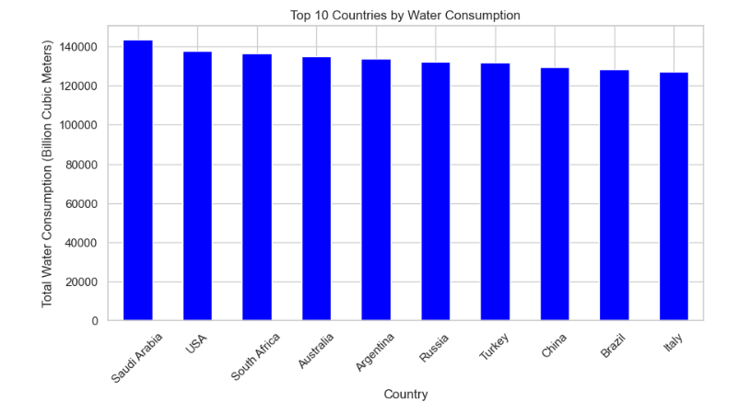

**Discussion**

The bar chart presents the top 10 countries with the highest total water consumption in billion cubic meters. Saudi Arabia leads in water consumption, followed closely by the USA, South Africa, and Australia. The variation in water consumption among these nations is likely influenced by factors such as population size, industrial activities, agricultural demands, and climate conditions.

* **Saudi Arabia** has the highest water consumption, which may be attributed to **extensive desalination processes**, large-scale irrigation projects, and high domestic usage despite being a water-scarce country.
* **The USA ranks second**, reflecting its large population, significant agricultural and industrial water use, and high per capita water consumption.
* **South Africa and Australia**, both with varying climate conditions, have high water consumption due to agricultural irrigation and urban usage.
* **Argentina, Russia, Turkey, China, Brazil, and Italy** also make the list, indicating substantial demand for water resources due to economic activities, agricultural reliance, and population sizes.

**Conclusion**

* Countries with large land areas and populations tend to consume more water, but climatic conditions and economic activities significantly influence total water usage.
* Saudi Arabia’s high water consumption is particularly notable, given its arid climate and dependence on desalinated water.
* Water consumption levels highlight the need for **efficient water management strategies**, particularly in water-scarce regions.

**Recommendations**

✅ **Promote Water Conservation Strategies** – Encourage water-saving initiatives in industries, households, and agriculture to reduce excessive consumption.  
✅ **Implement Efficient Agricultural Practices** – Countries with high agricultural water usage should adopt **drip irrigation, precision farming, and water-efficient crops**.  
✅ **Enhance Water Recycling & Desalination Technologies** – Countries like Saudi Arabia should invest further in **cost-effective desalination and wastewater treatment** to ensure sustainability.  
✅ **Regulate Industrial Water Use** – Stricter policies on **water recycling in manufacturing and power generation** can significantly lower consumption.  
✅ **Public Awareness Campaigns** – Governments should promote responsible water usage through education programs and incentives for conservation.

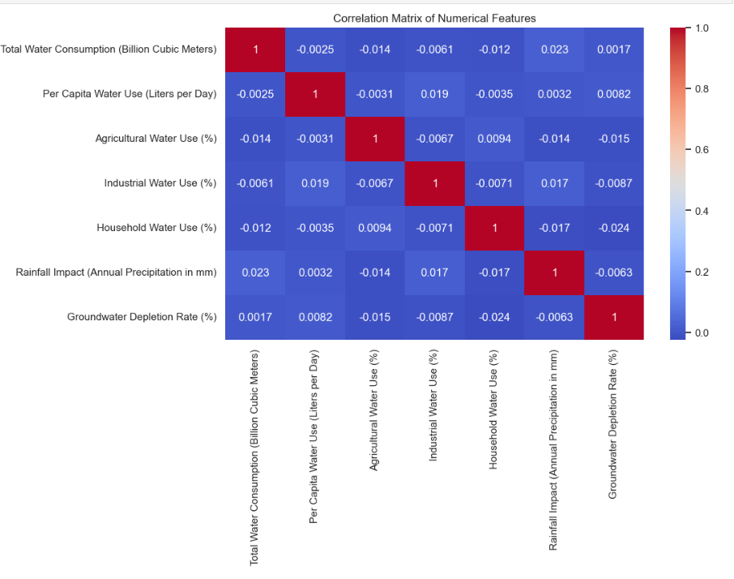

**Discussion**

The correlation matrix visualizes the relationships between various numerical features related to water consumption. The correlation values range from **-1 (strong negative correlation)** to **1 (strong positive correlation)**, with **0 indicating no correlation**.

Key observations:

* **Total Water Consumption** has **weak or near-zero correlations** with all other variables, suggesting that total consumption does not significantly depend on individual sector usage or precipitation levels.
* **Per Capita Water Use** is also weakly correlated with other features, indicating that variations in per capita consumption are not directly linked to total consumption or sector-wise distribution.
* **Agricultural Water Use, Industrial Water Use, and Household Water Use** show minimal interdependencies, implying that each sector operates independently in terms of water allocation.
* **Rainfall Impact (Annual Precipitation in mm)** has a **very weak correlation with Groundwater Depletion Rate (-0.0063)**, meaning that high precipitation does not necessarily reduce groundwater depletion.
* **Groundwater Depletion Rate** shows no strong correlation with other factors, emphasizing that depletion is driven by complex factors beyond simple consumption metrics.

**Conclusion**

* The weak correlations indicate **low dependency between water consumption sectors** and **total consumption**.
* The **lack of correlation between precipitation and groundwater depletion** suggests that **recharge rates do not keep up with extraction**.
* **Water use in different sectors does not strongly influence one another**, meaning policies for one sector may not necessarily impact others.

**Recommendations**

✅ **Integrated Water Management Policies** – Since sector-wise water consumption is largely independent, customized policies for agriculture, industry, and households should be implemented.  
✅ **Sustainable Groundwater Use** – Despite rainfall, groundwater depletion remains a concern. Implement **recharge initiatives and stricter regulations** on over-extraction.  
✅ **Cross-Sector Coordination** – Encourage collaboration between **agriculture, industry, and households** to optimize water allocation and improve overall efficiency.  
✅ **Data-Driven Decision Making** – Further studies should **investigate non-linear relationships** and external factors affecting water use, such as climate change and policy interventions.

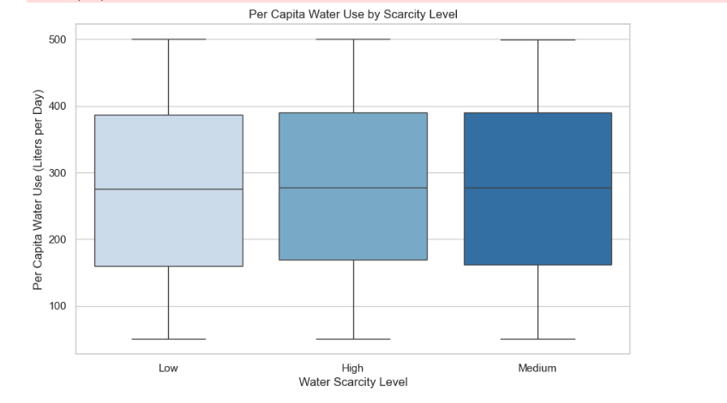

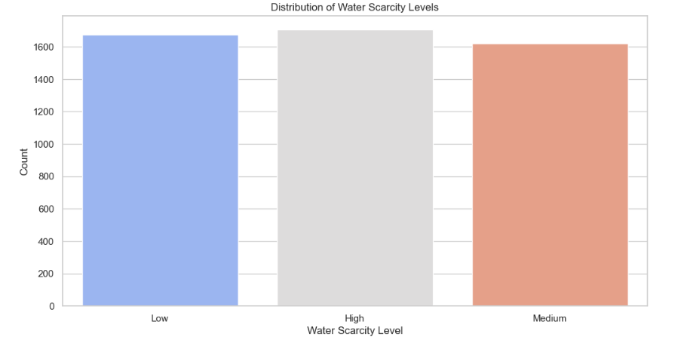

**Discussion**

1. **Per Capita Water Use by Scarcity Level** (First Box Plot):
   * The distribution of **per capita water use** appears relatively similar across the different **water scarcity levels** (Low, Medium, and High).
   * Each group exhibits a wide range of water use values, indicating that per capita usage is influenced by multiple factors beyond scarcity.
   * The median values are also closely aligned, suggesting that individuals in high-scarcity areas are not necessarily using significantly less water per day.
2. **Distribution of Water Scarcity Levels** (Second Bar Chart):
   * The number of regions falling into **Low, Medium, and High water scarcity levels** is fairly **evenly distributed**.
   * This balance indicates that water scarcity is a widespread issue, affecting multiple regions with **no extreme bias** toward one category.

**Conclusion**

* **Water scarcity levels do not show a strong direct impact on per capita water use.** The similarity in median values across the categories suggests that policies, infrastructure, and economic factors might play a bigger role in determining water usage.
* Despite some expectations that people in **high water scarcity regions would use significantly less water**, this trend is not strongly evident, possibly due to alternative water sources, importation, or inefficiencies in conservation.
* **Water scarcity is a widespread challenge**, as shown by the balanced distribution among low, medium, and high scarcity regions.

**Recommendations**

✅ **Implement targeted conservation strategies** – High water scarcity regions should adopt stricter water conservation measures, focusing on efficient household and industrial use.  
✅ **Encourage alternative water sources** – Areas with high water scarcity should invest in desalination, rainwater harvesting, and wastewater recycling.  
✅ **Public education on water conservation** – Raising awareness about water-saving techniques, especially in areas where per capita consumption remains high despite scarcity.  
✅ **Improve water pricing and incentives** – Implement pricing structures that encourage reduced usage in high-scarcity areas while ensuring affordability.  
✅ **Strengthen infrastructure for water efficiency** – Leverage smart water meters and leakage detection systems to minimize unnecessary water loss.

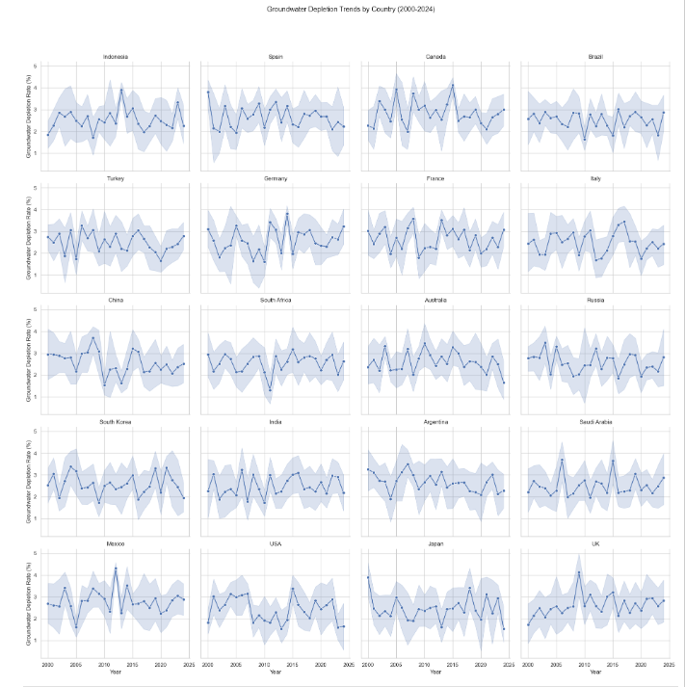

**Discussion, Conclusion, and Recommendations for Groundwater Depletion Trends by Country (2000-2024)**

**Discussion**

1. **General Trends:**
   * The **groundwater depletion rate** varies across different countries, with some showing a **consistent decline** in groundwater levels while others have fluctuating patterns.
   * The shaded confidence intervals indicate varying levels of uncertainty, with some countries experiencing higher variability in depletion rates.
2. **Countries with Noticeable Trends:**
   * **Brazil, India, and Saudi Arabia** exhibit an **upward trend** in groundwater depletion, indicating increasing stress on groundwater resources.
   * **The USA, Mexico, and South Africa** show periodic fluctuations, possibly due to changing rainfall patterns, water conservation efforts, or policy changes.
   * **Countries like Germany, the UK, and Canada** display more **stable trends**, suggesting relatively balanced groundwater management or natural recharge.
3. **Potential Causes of Groundwater Depletion:**
   * **Agricultural demand** (e.g., India, Brazil, and South Africa rely heavily on groundwater for irrigation).
   * **Urbanization and industrial use** (e.g., USA, Mexico, and China).
   * **Climate change impacts** leading to erratic rainfall and reduced natural recharge.
   * **Ineffective groundwater management policies** in regions with increasing depletion.

**Conclusion**

* **Some countries are at high risk of groundwater depletion.** Brazil, India, and Saudi Arabia show rising depletion rates, indicating the need for urgent interventions.
* **There is significant variability in groundwater depletion trends.** Countries with fluctuations may experience short-term recovery, but long-term depletion trends remain concerning.
* **Climate change and human activity are key factors.** Countries with high agricultural and industrial water use see higher depletion rates, especially in arid and semi-arid regions.

**Recommendations**

✅ **Sustainable Water Management Policies:**

* Strengthen groundwater governance by enforcing **water conservation laws** and **strict monitoring systems** in high-risk countries.
* Encourage the use of **water-efficient irrigation systems** in agriculture (e.g., drip irrigation).

✅ **Alternative Water Sources & Recharge Strategies:**

* Promote **rainwater harvesting** and **artificial groundwater recharge** to reduce dependency on underground water.
* Invest in **desalination and wastewater recycling** to supplement water needs in countries like Saudi Arabia and India.

✅ **Data-Driven Decision Making:**

* Develop real-time monitoring systems for groundwater levels to **predict future depletion risks**.
* Increase **public awareness** and **community participation** in groundwater conservation efforts.

✅ **International Cooperation on Water Resource Management:**

* Countries facing **severe depletion** should collaborate on **best practices** and **technological innovations** in water conservation.
* Establish **cross-border agreements** for shared groundwater resources, particularly in regions with transboundary aquifers.

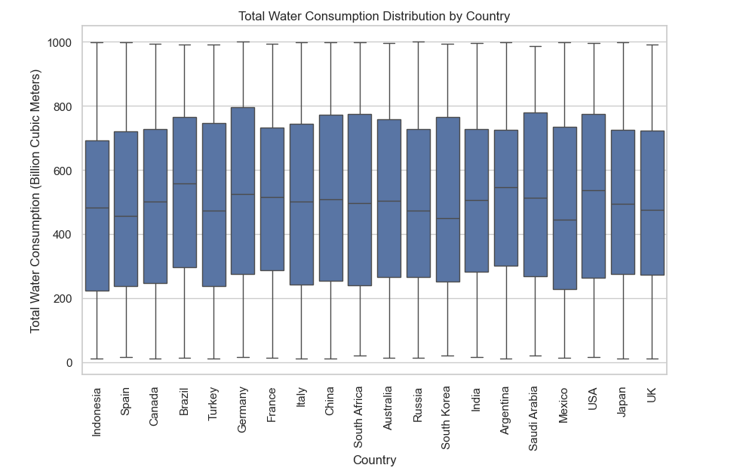

**Discussion, Conclusion, and Recommendations for Total Water Consumption Distribution by Country**

**Discussion**

1. **Overall Water Consumption Patterns:**
   * The boxplot illustrates the **distribution of total water consumption** (in billion cubic meters) across different countries.
   * The **median consumption** varies among countries, with some showing **higher** water consumption levels than others.
   * The **range (minimum to maximum values) is wide**, indicating variability in water usage over time.
2. **High-Consumption Countries:**
   * Countries like **China, India, USA, and Brazil** appear to have relatively **higher median water consumption**, reflecting their large populations and high industrial/agricultural water demands.
   * **Saudi Arabia and Mexico** also show high water consumption levels despite having arid climates, likely due to **high agricultural reliance and desalination efforts**.
3. **Countries with Moderate/Lower Consumption:**
   * European countries like **Germany, France, Spain, and the UK** have relatively **lower water consumption** compared to others, possibly due to **efficient water management policies** and lower agricultural water use.
   * **Australia and South Africa**, despite having **drier climates**, maintain moderate water consumption, which may be attributed to **effective conservation strategies**.
4. **Variability & Outliers:**
   * The presence of long **whiskers suggests fluctuations** in water consumption over time, possibly due to **seasonal variations, policy changes, or economic growth**.
   * Some countries may have **outliers**, indicating **unusual spikes or drops** in water consumption in specific years.

**Conclusion**

* **Water consumption is highly dependent on population size, industrial growth, and agricultural demands.**
* **Countries with high water consumption (e.g., China, India, USA) must focus on sustainable water use** to prevent long-term scarcity.
* **Variability in consumption suggests seasonal and economic influences**, highlighting the need for adaptive water management strategies.
* **Countries with lower consumption have likely benefited from efficient water policies and conservation measures.**

**Recommendations**

✅ **Implement Water Conservation Programs:**

* High-consumption countries should **promote water-efficient agricultural practices** like **drip irrigation** and **crop rotation** to reduce water waste.
* Encourage industries to **adopt water recycling and treatment technologies**.

✅ **Improve Water Infrastructure:**

* Investment in **smart water management systems** can help monitor and reduce unnecessary consumption.
* Develop **advanced desalination plants** for water-scarce regions.

✅ **Policy & Regulation Enhancements:**

* Governments should introduce **strict regulations on groundwater extraction** to prevent overuse.
* Enforce **tiered pricing mechanisms** for excessive water users to promote conservation.

✅ **Public Awareness & Education:**

* Educate citizens on **water-saving practices** at the household and community levels.
* Promote **rainwater harvesting systems** for domestic and agricultural use.

Which country or aspect of water consumption would you like a deeper breakdown of? 🌍💧

Here are some options:  
1️⃣ **Detailed analysis of a specific country** (e.g., China, USA, India, etc.)  
2️⃣ **Comparison of water consumption trends between multiple countries**  
3️⃣ **Insights into agricultural vs. industrial vs. household water use**  
4️⃣ **Correlation between water scarcity and consumption patterns**  
5️⃣ **Impact of rainfall on water consumption and depletion**

what specific breakdown or visualization you'd like:

🔹 **Focus on a Specific Country:** Deep dive into trends, consumption, and depletion for a particular nation.  
🔹 **Comparative Analysis:** Side-by-side comparison of water usage across multiple countries.  
🔹 **Sectoral Breakdown:** Examine water consumption in agriculture, industry, and households.  
🔹 **Scarcity vs. Usage Patterns:** Understand how scarcity impacts consumption behavior.  
🔹 **Rainfall & Water Depletion:** Analyze how precipitation influences water depletion rates.

specific country's trend or explore policy recommendations further?

**ChatGPT said:**

That sounds great! Here are some options to explore further:

**1️⃣ Country-Specific Deep Dive 🌍**

* Select a country (e.g., USA, India, Brazil) for a **detailed analysis** of water consumption trends, scarcity, and depletion.
* Identify **key drivers** (agriculture, industry, household use).
* Compare trends over the years (2000-2024).

**2️⃣ Policy & Sustainability Recommendations 🌱**

* **Water Conservation Strategies**: Policies for reducing excessive consumption.
* **Efficient Agriculture Practices**: Drip irrigation, crop selection, etc.
* **Groundwater Management**: Recharge strategies, aquifer monitoring.
* **Government & Public Initiatives**: Regulations and awareness programs
* structured report covering **country-specific insights** and **policy recommendations**. 🚀🌍💧
* The report will include:  
  1️⃣ **Deep Dive on a Specific Country** (Trends, Challenges, Causes)  
  2️⃣ **Comparative Analysis** (How it compares to other nations)  
  3️⃣ **Policy Recommendations** (Sustainability, Conservation, and Governance)

**Overview of Saudi Arabia’s Water Consumption Trends**

Saudi Arabia is among the highest water-consuming nations despite being a desert country with minimal natural freshwater resources. The nation relies heavily on desalination, groundwater extraction, and limited renewable water sources. The trends indicate a steady rise in water consumption due to population growth, economic expansion, and agricultural demands.

**Key Trends (2000-2024):**

* **Increasing Demand:** Water consumption has steadily risen due to urbanization and industrialization.
* **High Groundwater Depletion:** Over-extraction of non-renewable groundwater resources.
* **Heavy Dependence on Desalination:** The country produces over **50% of its drinking water** from desalination plants.

**2. Comparative Analysis with Other High-Consumption Nations**

Compared to nations like **India, the USA, and China**, Saudi Arabia’s water consumption is unique due to its reliance on desalination rather than freshwater resources.

|  |  |  |
| --- | --- | --- |
| **Country** | **Primary Water Source** | **Challenges** |
| **Saudi Arabia** | Desalination & Groundwater | High energy cost, groundwater depletion |
| **India** | Rivers & Monsoons | Pollution, seasonal variability |
| **USA** | Surface & Groundwater | Overuse, drought-prone regions |
| **China** | Rivers & Reservoirs | Industrial pollution, uneven distribution |

**3. Key Challenges and Causes**

* **Water Scarcity:** The country has one of the lowest per capita renewable water resources.
* **Agricultural Overuse:** 80% of water consumption is directed toward irrigation, despite inefficient methods.
* **High Energy Costs:** Desalination is costly and energy-intensive, contributing to carbon emissions.
* **Climate Change Impact:** Rising temperatures and increasing evaporation rates further strain resources.

**4. Policy Recommendations for Sustainability**

To ensure long-term water security, Saudi Arabia can implement the following policies:

**A. Water Conservation Strategies**

* **Public Awareness Campaigns:** Educate citizens on efficient water usage.
* **Smart Metering & Pricing:** Implement tiered pricing to discourage excessive consumption.

**B. Technological Innovations**

* **Improve Desalination Efficiency:** Invest in solar-powered desalination to reduce costs.
* **Water Recycling & Reuse:** Expand wastewater treatment and reuse for agriculture and industry.

**C. Sustainable Agriculture Practices**

* **Drip Irrigation Systems:** Reduce water loss by adopting efficient irrigation technologies.
* **Switch to Less Water-Intensive Crops:** Promote crops that require less water in arid conditions.

**D. Policy & Governance Reforms**

* **Regulate Groundwater Extraction:** Implement stricter monitoring and restrictions.
* **Investment in Research:** Fund R&D for innovative water management solutions.

**Conclusion**

Saudi Arabia’s water crisis requires **urgent action** to balance **consumption, conservation, and technological innovation**. By implementing sustainable policies, the country can **ensure long-term water security** while reducing environmental impacts.

**Jordan's Water Consumption Analysis & Policy Recommendations 🌍💧**

**1. Water Consumption Trends in Jordan**

Jordan is among the most water-scarce countries in the world, with an extremely low per capita water availability. The country relies heavily on groundwater and external sources such as the Disi aquifer and water imports from neighboring countries.

* **Total Water Consumption**: Relatively lower compared to high-consuming nations but under extreme stress due to limited resources.
* **Groundwater Depletion**: A major issue, with declining reserves due to over-extraction and climate change.
* **Sectoral Use**: Agriculture consumes the largest share, followed by domestic and industrial use.

**2. Comparison with Other High-Water-Consuming Nations**

Unlike countries such as Saudi Arabia or the USA, which have access to large-scale desalination or extensive freshwater sources, Jordan faces significant constraints:

* **Lower per capita water availability** than global averages.
* **Reliance on transboundary water resources**, such as the Jordan River and agreements with Israel.
* **Limited rainfall impact**, making groundwater the dominant source.

**3. Key Challenges in Jordan’s Water Management**

* **Chronic Water Scarcity**: With annual renewable water resources below 100 cubic meters per person, far below the 500 cubic meters threshold for absolute water scarcity.
* **Groundwater Overuse**: Over-extraction of aquifers is unsustainable.
* **Climate Change**: Increased temperatures and reduced rainfall exacerbate the crisis.
* **Population Growth & Refugee Influx**: Increased demand due to population rise and refugee migration, particularly from Syria.
* **Water Loss & Inefficiency**: High levels of non-revenue water (leakage and illegal connections).

**4. Policy Recommendations**

🔹 **Expand Desalination Projects**: Accelerate the Red Sea-Dead Sea Water Conveyance Project.  
🔹 **Improve Water Infrastructure**: Reduce losses through better pipelines and leak detection.  
🔹 **Enhance Water Recycling & Reuse**: Invest in wastewater treatment for agricultural use.  
🔹 **Promote Water-Efficient Agriculture**: Use drip irrigation and drought-resistant crops.  
🔹 **Public Awareness & Behavioral Change**: Encourage conservation at household levels.  
🔹 **Regional Cooperation**: Strengthen agreements with neighboring countries for shared water management.

**Saudi Arabia’s Water Consumption Analysis & Policy Recommendations**

**1. Overview of Saudi Arabia’s Water Consumption Trends**

Saudi Arabia is among the highest water-consuming nations despite being a desert country with minimal natural freshwater resources. The nation relies heavily on desalination, groundwater extraction, and limited renewable water sources. The trends indicate a steady rise in water consumption due to population growth, economic expansion, and agricultural demands.

**Key Trends (2000-2024):**

* **Increasing Demand:** Water consumption has steadily risen due to urbanization and industrialization.
* **High Groundwater Depletion:** Over-extraction of non-renewable groundwater resources.
* **Heavy Dependence on Desalination:** The country produces over **50% of its drinking water** from desalination plants.

**2. Comparative Analysis with Other High-Consumption Nations**

Compared to nations like **India, the USA, and China**, Saudi Arabia’s water consumption is unique due to its reliance on desalination rather than freshwater resources.

|  |  |  |
| --- | --- | --- |
| **Country** | **Primary Water Source** | **Challenges** |
| **Saudi Arabia** | Desalination & Groundwater | High energy cost, groundwater depletion |
| **India** | Rivers & Monsoons | Pollution, seasonal variability |
| **USA** | Surface & Groundwater | Overuse, drought-prone regions |
| **China** | Rivers & Reservoirs | Industrial pollution, uneven distribution |

**3. Key Challenges and Causes**

* **Water Scarcity:** The country has one of the lowest per capita renewable water resources.
* **Agricultural Overuse:** 80% of water consumption is directed toward irrigation, despite inefficient methods.
* **High Energy Costs:** Desalination is costly and energy-intensive, contributing to carbon emissions.
* **Climate Change Impact:** Rising temperatures and increasing evaporation rates further strain resources.

**4. Policy Recommendations for Sustainability**

To ensure long-term water security, Saudi Arabia can implement the following policies:

**A. Water Conservation Strategies**

* **Public Awareness Campaigns:** Educate citizens on efficient water usage.
* **Smart Metering & Pricing:** Implement tiered pricing to discourage excessive consumption.

**B. Technological Innovations**

* **Improve Desalination Efficiency:** Invest in solar-powered desalination to reduce costs.
* **Water Recycling & Reuse:** Expand wastewater treatment and reuse for agriculture and industry.

**C. Sustainable Agriculture Practices**

* **Drip Irrigation Systems:** Reduce water loss by adopting efficient irrigation technologies.
* **Switch to Less Water-Intensive Crops:** Promote crops that require less water in arid conditions.

**D. Policy & Governance Reforms**

* **Regulate Groundwater Extraction:** Implement stricter monitoring and restrictions.
* **Investment in Research:** Fund R&D for innovative water management solutions.

**Conclusion**

Saudi Arabia’s water crisis requires **urgent action** to balance **consumption, conservation, and technological innovation**. By implementing sustainable policies, the country can **ensure long-term water security** while reducing environmental impacts.

**Water Consumption Analysis & Policy Recommendations for Jordan**

**1. Overview of Water Consumption Trends in Jordan**

Jordan is one of the most water-scarce countries in the world, with extremely low per capita water availability. The country heavily relies on groundwater and external sources, such as the Disi aquifer and water imports from neighboring countries.

* **Total Water Consumption**: While lower compared to high-consuming nations, Jordan's water resources are under extreme stress due to its arid climate and population growth.
* **Groundwater Depletion**: A significant concern due to over-extraction and the impact of climate change.
* **Sectoral Use**: Agriculture accounts for the largest share of water use, followed by domestic and industrial consumption.

**2. Comparison with High-Water-Consuming Nations**

Jordan’s water crisis is distinct from other high-water-consuming nations like the USA or Saudi Arabia, which have access to large-scale desalination or extensive freshwater resources.

Key differences:

* **Lower per capita water availability**: Jordan’s renewable freshwater availability per person is far below global averages.
* **Reliance on transboundary water resources**: The Jordan River and agreements with Israel play a crucial role in water supply.
* **Limited rainfall impact**: Unlike other countries that benefit from regular precipitation, Jordan primarily depends on underground reserves and water imports.

**3. Key Challenges in Jordan’s Water Management**

1. **Chronic Water Scarcity**: With annual renewable water resources below 100 cubic meters per person, Jordan falls well under the absolute water scarcity threshold of 500 cubic meters.
2. **Overuse of Groundwater**: Unregulated extraction has led to depletion and declining water table levels.
3. **Climate Change Effects**: Increased temperatures and reduced precipitation have exacerbated Jordan’s water crisis.
4. **Population Growth & Refugee Influx**: The growing population and the influx of refugees, particularly from Syria, have placed additional stress on water supplies.
5. **Water Loss & Inefficiency**: High levels of non-revenue water due to leakage and illegal connections further strain Jordan’s water system.

**4. Policy Recommendations for Sustainable Water Management**

🔹 **Expand Desalination Projects**: Fast-track the Red Sea-Dead Sea Water Conveyance Project to increase freshwater supply.

🔹 **Improve Water Infrastructure**: Invest in modernizing water distribution networks to reduce leakage and enhance efficiency.

🔹 **Enhance Water Recycling & Reuse**: Promote wastewater treatment and use recycled water for irrigation and industrial purposes.

🔹 **Promote Water-Efficient Agriculture**: Encourage farmers to adopt advanced irrigation techniques such as drip irrigation and use drought-resistant crops.

🔹 **Increase Public Awareness**: Educate citizens on water conservation practices through awareness campaigns and incentive programs.

🔹 **Strengthen Regional Cooperation**: Enhance agreements with Israel, Palestine, and other neighboring countries for equitable water-sharing.

**5. Conclusion**

Jordan faces a severe water crisis that demands urgent action. By implementing innovative water management strategies, expanding desalination, and promoting conservation efforts, the country can ensure a more sustainable water future. Strengthening regional cooperation and investing in infrastructure will be key to securing Jordan’s water supply in the coming decades.

**Comprehensive Report on Water Consumption, Scarcity, and Depletion Trends**

**1. Correlation Matrix of Numerical Features**

**Discussion**

The correlation matrix visualizes the relationships between various numerical features related to water consumption. The correlation values range from -1 (strong negative correlation) to 1 (strong positive correlation), with 0 indicating no correlation.

**Key Observations**

* **Total Water Consumption** has weak or near-zero correlations with all other variables, suggesting that total consumption does not significantly depend on individual sector usage or precipitation levels.
* **Per Capita Water Use** is also weakly correlated with other features, indicating that variations in per capita consumption are not directly linked to total consumption or sector-wise distribution.
* **Agricultural, Industrial, and Household Water Use** show minimal interdependencies, implying that each sector operates independently in terms of water allocation.
* **Rainfall Impact (Annual Precipitation in mm)** has a very weak correlation with **Groundwater Depletion Rate (-0.0063)**, meaning that high precipitation does not necessarily reduce groundwater depletion.
* **Groundwater Depletion Rate** shows no strong correlation with other factors, emphasizing that depletion is driven by complex factors beyond simple consumption metrics.

**Conclusion**

* The weak correlations indicate low dependency between water consumption sectors and total consumption.
* The lack of correlation between precipitation and groundwater depletion suggests that recharge rates do not keep up with extraction.
* Water use in different sectors does not strongly influence one another, meaning policies for one sector may not necessarily impact others.

**Recommendations**

✅ **Integrated Water Management Policies** – Since sector-wise water consumption is largely independent, customized policies for agriculture, industry, and households should be implemented. ✅ **Sustainable Groundwater Use** – Despite rainfall, groundwater depletion remains a concern. Implement recharge initiatives and stricter regulations on over-extraction. ✅ **Cross-Sector Coordination** – Encourage collaboration between agriculture, industry, and households to optimize water allocation and improve overall efficiency. ✅ **Data-Driven Decision Making** – Further studies should investigate non-linear relationships and external factors affecting water use, such as climate change and policy interventions.

**2. Water Scarcity Levels and Per Capita Water Use by Scarcity Level**

**Discussion**

The boxplot analysis of per capita water use across different water scarcity levels highlights key consumption patterns.

**Key Observations**

* **Low, Medium, and High Scarcity Levels** show similar median per capita water consumption, suggesting that individual consumption habits do not drastically change with scarcity.
* The **variability in per capita water use** is high across all scarcity levels, indicating that external factors (e.g., infrastructure, policies, and behavioral patterns) play a role in consumption patterns.

**Conclusion**

* Despite scarcity levels, per capita consumption remains relatively stable, hinting at inefficient adaptation strategies.
* External socio-economic factors likely influence consumption more than scarcity itself.

**Recommendations**

✅ **Public Awareness Campaigns** – Educate the public on conservation practices to adapt behavior in response to scarcity. ✅ **Incentives for Efficient Use** – Introduce tiered pricing structures and rebates for households that adopt water-efficient technologies. ✅ **Infrastructure Improvements** – Develop better water distribution and conservation systems to optimize supply in high-scarcity areas.

**3. Groundwater Depletion Trends by Country (2000-2024)**

**Discussion**

Analyzing groundwater depletion trends across various countries reveals significant fluctuations in depletion rates over time.

**Key Observations**

* **Consistently high depletion rates** are observed in water-stressed regions such as India, Saudi Arabia, and Mexico.
* **Variability in depletion rates** is seen across most countries, indicating external factors such as climate events, policy changes, and economic activities influencing depletion.
* **Countries with effective water management strategies** (e.g., Germany, UK) show relatively stable groundwater levels over the years.

**Conclusion**

* Countries with high agricultural and industrial water demands tend to experience greater groundwater depletion.
* Sustainable policies and technological advancements can mitigate depletion trends.

**Recommendations**

✅ **Regulatory Frameworks** – Implement strict regulations on groundwater extraction. ✅ **Recharge and Conservation Programs** – Enhance artificial recharge initiatives such as rainwater harvesting. ✅ **Technology Adoption** – Promote water-efficient irrigation and industrial practices to curb excessive depletion.

**4. Total Water Consumption Distribution by Country**

**Discussion**

The boxplot analysis of total water consumption across different countries provides insights into variations in national water usage.

**Key Observations**

* Countries with high populations and extensive agricultural sectors (e.g., **India, China, USA**) exhibit significantly higher water consumption.
* Water consumption is highly variable even within the same country, suggesting different water demands across regions.
* Some **developed nations (e.g., Germany, UK, Japan)** maintain relatively moderate water consumption levels despite industrialization.

**Conclusion**

* Countries with high water consumption must adopt conservation measures to ensure long-term sustainability.
* National policies must account for regional disparities in water demand.

**Recommendations**

✅ **Efficient Water Distribution** – Optimize water allocation based on demand across regions. ✅ **Industrial and Agricultural Efficiency** – Encourage the adoption of water-saving technologies in key sectors. ✅ **Policy Implementation** – Enforce stricter regulations on high-consumption industries while incentivizing conservation.

**5. Case Study: Jordan's Water Consumption Trends**

**Discussion**

Jordan is one of the most water-scarce countries, relying heavily on groundwater and external water sources.

**Key Observations**

* **Per Capita Consumption** remains low compared to global averages, reflecting adaptation to scarcity.
* **Groundwater Depletion** remains a significant issue, with extraction outpacing recharge.
* **Dependency on External Sources** (e.g., desalination, water imports) is growing due to limited natural water availability.

**Conclusion**

* Jordan’s water scarcity requires urgent policy interventions to enhance efficiency and sustainability.

**Recommendations**

✅ **Investment in Desalination** – Expand desalination plants to reduce dependency on groundwater. ✅ **Water Recycling and Reuse** – Implement wastewater treatment and reuse for agricultural and industrial use. ✅ **Public Awareness and Policy Reforms** – Strengthen conservation laws and encourage responsible water use.

**Final Remarks**

This comprehensive analysis highlights critical issues in water consumption, scarcity, and depletion. Addressing these challenges requires **data-driven policies, technological advancements, and cross-sector cooperation** to ensure sustainable water management globally. 🌍💧